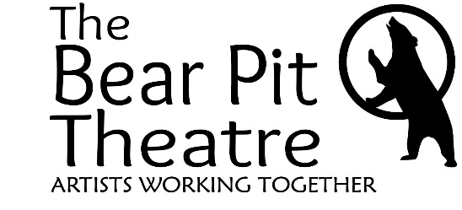
The Bear Pit Theatre Company
Members Code of Conduct

General Conduct
As a member of The Bear Pit Theatre, you agree to:
- Treat all individuals with respect and dignity, regardless of age, gender, race, religion, or background.
- Uphold the values of The Bear Pit Theatre by fostering an inclusive, welcoming, and creative environment.
- Communicate openly and respectfully with other members, volunteers, and theatre staff.
- Represent The Bear Pit Theatre positively within the wider community.
- Show respect in all interactions, whether in person, online, or on social media.

Safeguarding & Working with Children
The Bear Pit Theatre is committed to creating a safe environment for everyone, particularly children and vulnerable adults. As a member, you agree to:
- Prioritise the safety and well-being of children and vulnerable adults at all times.
- Follow The Bear Pit Theatre’s safeguarding policies and procedures.
- Maintain appropriate physical and emotional boundaries when interacting with children and vulnerable individuals.
- Report any safeguarding concerns immediately to the Designated Safeguarding Officer (DSO) or an appropriate theatre representative.
- Ensure that any photography or filming of children is only undertaken with the explicit permission of a Designated Safeguarding Officer and in accordance with theatre policies.
- Only photograph or film children with the explicit permission of a DSO and in accordance with theatre policies.
We take all safeguarding matters seriously. If a concern is raised, it will be investigated promptly and, if necessary, reported to the relevant authorities.

Consequences of Violations
The Bear Pit Theatre is committed to maintaining a safe, respectful, and welcoming environment. If a member is found to be in breach of this Code of Conduct, the following actions may be taken:
- Informal Discussion – For minor breaches, a friendly reminder or conversation may be held to address the issue.
- Formal Warning – If behaviour continues or the breach is more serious, a formal warning may be issued.
- Membership Review – In cases of repeated or serious breaches, membership may be reviewed, and restrictions may be placed on involvement in productions or events.
- Membership Revocation – If a member is found to have committed a serious breach of conduct, including safeguarding violations or behaviour that endangers others, their membership may be revoked.

Conclusion & Agreement Statement
By becoming a member of The Bear Pit Theatre, you agree to uphold this Code of Conduct and contribute to a positive, inclusive, and respectful community.
This Code exists to ensure that The Bear Pit Theatre remains a safe and welcoming space for all. We appreciate your commitment to these values and look forward to working together to create great theatre.
By signing up for membership, you are confirming that you have read and agree to this Code of Conduct.

