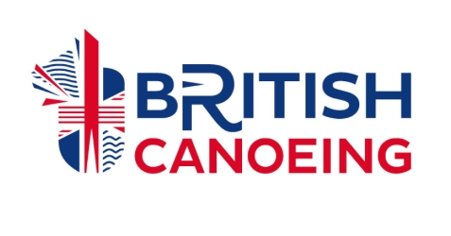
TAUNTON CANOE CLUB – YOUTH CODE OF CONDUCT

As a youth paddler taking part in a Taunton Canoe Club activity, you should:

- Help create and maintain an environment free of fear and harassment.
- Demonstrate fair play and apply British Canoeing’s standards both on and off the water.
- Understand that you have the right to be treated as an individual.
- Respect the advice that you receive.
- Treat others as you would wish to be treated yourself.
- Respect other people and their differences.
- Look out for yourself and for the welfare of others.
- Speak out (to your parents or a club representative) if you consider that you or others have been poorly treated.
- Tell someone in authority if you are leaving the venue.
- Accept that these guidelines are in place for the well-being of all concerned.
- Treat organisers and coaches with respect.
- Observe instructions or restrictions requested by the adults looking after you.
- Be organised and on time, or inform your coach if you are going to be late.
- Take care of all property belonging to the club or any club member – and be responsible for caring for your own equipment and clothing.

- You should not take part in any irresponsible, abusive, inappropriate or illegal behaviour which includes: Using offensive language. Publicly using critical or disrespectful descriptions of others either in person or through text, email or social network sites.
- You should not smoke or consume alcohol / drugs of any kind whilst on club premises or representing the club at events.

Last reviewed by the committee 5/10/2023

