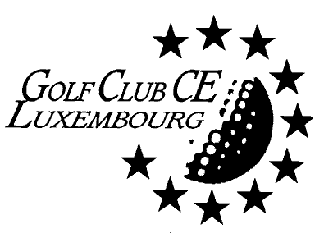

Luxembourg, 25 March 2017

EASTER BUNNY COMPETITION,
Golf de Luxembourg, BELENHAFF
FRIDAY 14 April 2017

You are cordially invited to participate in our Easter Bunny Competition. Following tradition this competition will be played at Belenhaff; on Friday 14 April. The tournament will be followed by a prize-giving.

The formula and categories will be decided upon when the number of participants is known.

Handicaps: 0 to 36, green cards and non handicaps (who will have to play with a 36 handicap).

The deadline for entries is Friday 7 April 2017

Starting times will be sent to you as soon as they are available.

First Tee-time at 12h30

Players are reminded to arrive at the first tee no later than ten minutes before their allotted tee-off time.

Greenfee for non-members of Belenhaff € 53 for adults and € 40 for juniors, to be transferred to the account of the club: BIL IBAN LU07 0025 1597 4376 8500 - mention "Easter Bunny 2017".

We hope to see many of you in Belenhaff.
The Committee

------------------------------------------------------------------------------------------------------------------------
Entry form to be returned to Gert Nielsen
gnielsen@pt.lu

Name and Surname | . | Hcp |  | Belenhaff member | Yes
Name and Surname | ................................................. | Hcp | ............... | Belenhaff member | Yes / No
(Buggy has to be arranged individually directly with the golf secretariat : (+352) 78 00 68-1

