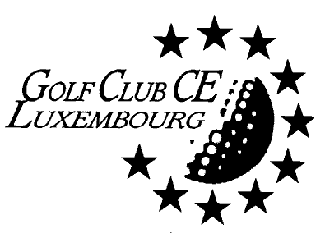

Luxembourg, 20 August 2021

Golf de Cherisey
Saturday 4TH of September 2021 from 11.am

Dear members,

Your Committee is happy to invite you to participate in a round of golf at Cherisey (located south of Metz, 38 Rue Principale, 57420 Chérisey – tel: 03 87 52 70 18), for a stableford competition.
The official site: https://jouer.golf/golf/ugolf-chateau-de-metz-cherisey/

Green fee will be 40,-€ (including card management),.

The course might be for some not that easy to walk (at least two or three holes uphill) if you’ll need a buggy, please note that it has to be booked individually by contacting directly the secretariat.

Deadline for entries will be 17.00 hrs on Sunday 29th of August 2021

The organiser will confirm your registration with the chosen option, so that you should transfer the total amount to the GCCE bank account:

BIL LU07 0025 1597 4376 8500 with the reference "Cherisey 2021".

-------------------------------------------------------------------------------------------------------------
Entry form to be returned to Fabrice: borntogolf@hotmail.fr

NAME and SURNAME  Green fee 40,-€/pers | Club | Hcp |  | Total  €
Specific issue(s):
(Like early or late tee time)

