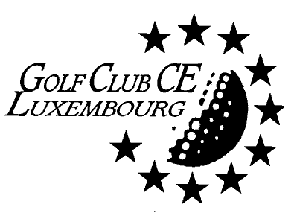

Luxembourg, 21 Juillet 2020

Week-End au Golf National de St Quentin en Yvelines (France)
On Saturday/Sunday 29/30 August 2020

For our 9th event of the year, your committee is pleased to invite all members to nothing else than the Albatros course of the Golf National, the scene of the last edition of the Ryder Cup in 2018.
You will walk on Saturday from 13:00 as well than on Sunday from 11:00 in the footsteps of our European Champions led by Thomas Bjørn, when they did outclassed the American armada of Jim Furyk.
This course will also host the Golf competition of the Paris Olympic Games in 2024.
Next to this mythical location, you will stay for a night directly on the golf course at the Novotel. The accommodation fees foresees one night, the Saturday three courses diner (including 1/3 wine, water and coffee), the Sunday breakfast as Morning Buffet, as well as a “snacking buffet” on Sunday after the round of golf.
ACCOMODATION | Room (Price/person)incl. Local taxes | Restaurants  (Price/person) | Total
Single occupation | 112,-€ | 70,-€ | 182,-€
Double occupation | 62,-€ | 70,-€ | 132,-€

Buggies (with GPS) might be ordered directly at the club-house if needed (48,-€ to be paid at the club-house), the course, quite easy to walk, remains a championship course, and is quite long.
Now, talking about the Greenfees, it’s not possible for the moment to give you the exact amount you will have to pay, because they will be strongly influenced by the number of participants (if we are 20 players, over the two days, we will get 2 free GF). Being the property of the French Federation, the Golf National offers also different fees depending if you have a french license (106,-€) or not (165,-€), but everyone might order the French License ( for 54,-€) among other to come for the two days to an amount of 266,-€ instead of 330,-€ per person (-Brutto- because on this amount, the club will subsidize each round with 25,-€).
So, in order to register to this very special venue, please send me back the table below, crossing the selected options, this before WEDNESDAY 29th of JULY, by end of business day.
Further information will be provided to the concerned participants during the second half of August.

The Golf National Site: https://www.golf-national.com, contact persons for our group: Laura, Christophe tel: +33 1 30 43 36 00, Novotel : Charlotte tel: +33 1 30 57 65 67.

So depending on your choice, you will have to transfer the corresponding amount to the account of the club: BIL IBAN LU07 0025 1597 4376 8500 – with the mention "Golf National 2020".

For the Committee,
Fabrice LEBRUN
---------------------------------------------------------------------------------------------------------------------------
Please send your entry form to Fabrice LEBRUN (fabrice.lebrun@publications.europa.eu)

Name & Surname | Home Club/Licence | Hdcp | Adult / Junior

Will participate in the event organized at Golf National (south of Paris) on the Saurday 29th and Sunday 30th of August 2020, and :

- Would like to book :
  - ……x Package SINGLE at 192,-€/person
  - ……x Package DOUBLE at 142,-€/ person …………… total: ,-€

- Would like to book the Group Green Fees as
  - Member of the French Golf Federation at 106,-€/pers/day total: ,-€
  - Member of another Golf Federation at 165,-€/pers/day total: ,-€

- Would like to by the French License 54,-€/pers (1) total: ,-€

Total BRUTTO : ,-€

- Club subsidy (-50,-€/pers) total: - ,-€

Total to be transfered : ,-€

- Please indicates hereafter you private address where do you want the French license to be send to:

